 ALERT MESSAGE NOTIFICATION ON ECOMMERCE WEBSITE

## A DESIGN PROJECT REPORT

***Submitted by***

**KABILAN D**

**MANIVASAGAM S**

**MOHANRAJ G**

**REMON AMBRISH J**

***in partial fulfillment for the award of the degree of***

# BACHELOR OF ENGINEERING

***in***

# COMPUTER SCIENCE AND ENGINEERING

**K. RAMAKRISHNAN COLLEGE OF TECHNOLOGY**

(An Autonomous Institution, affiliated to Anna University Chennai and Approved by AICTE, New Delhi)

**SAMAYAPURAM – 621 112**

## November, 2024

 ALERT MESSAGE NOTIFICATION ON ECOMMERCE WEBSITE

## A DESIGN PROJECT REPORT

***Submitted by***

**D KABILAN (811722104065)**

**S MANIVASAGAM (811722104087)**

**G MOHANRAJ (811722104091)**

**J REMON AMBRISH (811722104306)**

***in partial fulfillment for the award of the degree of***

# BACHELOR OF ENGINEERING

***in***

# COMPUTER SCIENCE AND ENGINEERING

**K. RAMAKRISHNAN COLLEGE OF TECHNOLOGY**

(An Autonomous Institution, affiliated to Anna University Chennai and Approved by AICTE, New Delhi)

**SAMAYAPURAM – 621 112**

**November, 2024**

# K. RAMAKRISHNAN COLLEGE OF TECHNOLOGY (AUTONOMOUS)

**SAMAYAPURAM – 621 112**

# BONAFIDE CERTIFICATE

Certified that this project report titled “ALERT MESSAGE NOTIFICATION ON ECOMMERCE WEBSITE ”is the Bonafide work of the students KABILAN.D(811721104091),MANIVASAGAM.S(811721104087),MOHANRAJ.G(811722104091),REMON AMBRISH. J(811722104306) who carried out the project under my supervision. Certified further, that to the best of my knowledge the work reported herein does not form part of any other project report or dissertation on the basis of which a degree or award was conferred on an earlier occasion on this or any other candidate.

|  |  |
| --- | --- |
| **SIGNATURE**  Dr. Delphin Carolina Rani, M.E, Ph.D**.,**  **HEAD OF THE DEPARTMENT**  **PROFESSOR**  Department of CSE  K. Ramakrishnan College of Technology (Autonomous)  Samayapuram – 621 112 | **SIGNATURE**  Mrs Mathumathi ,M.E..,  **SUPERVISOR**  **ASSISTANT PROFESSOR**  Department of CSE  K. Ramakrishnan College of Technology (Autonomous)  Samayapuram – 621 112 |

Submitted for the viva-voce examination held on …………….

**INTERNAL EXAMINER EXTERNAL EXAMINER**

# DECLARATION

We jointly declare that the project report on **“ALERT MESSAGE NOTIFICATION ON ECOMMERCE WEBSITE”** is the result of original work done by us and best of our knowledge, similar work has not been submitted to **“ANNA UNIVERSITY CHENNAI”** for the requirement of Degree of **BACHELOR OF ENGINEERING**. This project report is submitted on the partial fulfilment of the requirement of the award of Degree of **BACHELOR OF ENGINEERING**.

|  |
| --- |
| **Signature** |
| KABILAN D |
| MANIVASAGAM S  MOHANRAJ G  REMON AMBRISH J |

Place: Samayapuram Date:

# ACKNOWLEDGEMENT

It is with great pride that we express our gratitude and in-debt to our institution “**K. RAMAKRISHNAN COLLEGE OF TECHNOLOGY (AUTONOMOUS)**”, for providing us with the opportunity to do this project.

We are glad to credit honorable chairman **Dr. K. RAMAKRISHNAN**, **B.E.,**

for having provided for the facilities during the course of our study in college.

We would like to express our sincere thanks to our beloved Executive Director **Dr. S. KUPPUSAMY, MBA, Ph.D.,** for forwarding to our project and offering adequate duration in completing our project.

We would like to thank **Dr. N. VASUDEVAN, M . Tech , Ph.D.,**

Principal, who gave opportunity to frame the project the full satisfaction.

We heartily thanks to **Dr. DELPHIN CAROLINA RANI, M.E, Ph.D.,** Head of the department , **COMPUTER SCIENCE AND ENGINEERING** for providing her encourage pursuing this project.

I express my deep and sincere gratitude to my beloved project guide

**Mrs. MATHUMATHI M.E..,** Department of **COMPUTER SCIENCE AND**

**ENGINEERING,** for incalculable suggestions, creativity, assistance and patience which motivated me to carry out this project.

I render my sincere thanks to Course Coordinator and other staff members for providing valuable information during the course.

I wish to express my special thanks to the officials and Lab Technicians of our departments who rendered their help during the period of the work progress.

iv

# ABSTRACT

# ALERT MESSAGE NOTIFICATION ON ECOMMERCE WEBSITE have emerged as an essential tool for online shoppers and e-commerce platforms, offering real-time alerts when the prices of desired products decrease. These notifications serve to enhance the customer shopping experience by enabling users to make timely purchasing decisions, ensuring they take advantage of discounts or price reductions. Leveraging sophisticated algorithms, these systems track product prices across multiple retailers and send automated alerts via email, SMS, or mobile apps when a drop is detected. This not only empowers customers to save money but also increases engagement and loyalty to the platform.

# From a business perspective, ALERT MESSAGE NOTIFICATION ON ECOMMERCE WEBSITE can drive traffic to e-commerce sites and improve sales conversion rates by nudging users toward purchases they might otherwise delay. By providing personalized alerts based on individual user preferences and browsing history, companies can foster deeper customer relationships and enhance user retention. However, managing such notifications requires careful consideration of user preferences, notification frequency, and timing to avoid overwhelming customers. As e-commerce continues to grow, price drop notifications will likely play a pivotal role in shaping the future of online shopping, offering both strategic benefits to retailers and value-added services to consumers.

v

# TABLE OF CONTENTS

|  |  |  |
| --- | --- | --- |
| **CHAPTER** | **TITILE** | **PAGE NO** |
| **1** | **ABSTRACT**  **LIST OF TABLES LIST OF FIGURES**  **LIST OF ABBREVIATIONS**  **INTRODUCTION** | **v vi x xi**  **1** |
|  | 1.1 PROJECT OVERVIEW | 2 |
|  | 1.2 PROBLEM STATEMENT | 2 |
|  | 1.2.1 GOAL | 3 |
|  | 1.3 OBJECTIVES | 3 |
|  | 1.4 SCOPE OF THE PROJECT | 4 |
|  |  |  |

1. LITERATURE REVIEW 5

2.1 PRICE ALERTS ON CONSUMER PURCHASING BEHAVIOR 5

2.2 REAL-TIME PRICE TRACKING6

2.3 ECOMMERCE WEBSITES IN E-COMMERCE 7

EFFICIENCY WELFARE

2.4 CHALLENGES IN MESSAGE NOTIFICATION8

2.5 ECONOMICS FOR PRICE DROP ALERT 8

1. EXISTING SYSTEM 9
2. PROPOSED SYSTEM 10
3. SYSTEM ARCHITECTURE 11

5.1 DATA FLOW DIAGRAM 12

5.2 USE-CASE DIAGRAM 14

5.3 ACTIVITY DIAGRAM 15

5.4 SEQUENCE DIAGRAM 16

|  |  |  |
| --- | --- | --- |
| **6** | **SYSTEM REQUIREMENT**  6.1 HARDWARE REQUIREMENTS | **24**  **24** |
|  | 6.2 SOFTWARE REQUIREMENTS | 24 |
|  | 6.3 SOFTWARE DESCRIPTION | 24 |
|  | 6.3.1 WINDOWS 10 | 24 |
|  | 6.3.2 TKINTER | 25 |
|  | 6.3.3 PANDAS | 25 |
|  | 6.3.4 NUMPY | 26 |
|  | 6.4 TENSORFLOW – INTRODUCTION | 26 |
|  | 6.4.1 CONVOLUTIONAL NEURAL |  |
|  | NETWORKS | 28 |
|  | 6.5 KERAS INTRODUCTION | 29 |
|  | 6.5.1 MULTI-LAYER PERCEPTRON | 30 |
|  | 6.5.2 CONVOLUTIONAL NEURAL |  |
|  | NETWORK (CNN) | 31 |
|  | 6.6 PYTHON NUMPY | 32 |
|  | 6.6.1 THE NEED OF NUMPY | 32 |
|  | 6.7 PYTHON PILLOW – OVERVIEW | 32 |
|  | 6.7.1 IMAGE ARCHIVES | 33 |
|  | 6.7.2 IMAGE PROCESSING | 33 |
|  | 6.7.3 INSTALLING PILLOW USING PIP | 33 |
|  | 6.7.4 PYTHON PILLOW USING |  |
|  | IMAGE MODULE | 33 |
|  | 6.7.5 INSTALL SciPy USING PIP | 34 |

**7 SYSTEM TESTING** **35**

* 1. TESTING STEPS 35
     1. TYPES OF TESTS 35

7.1.1.1 UNIT TESTING 35

7.1.1.2 SYSTEM TESTING 36

7.1.1.3 BLACK BOX TESTING 36

7.1.1.4 WHITE BOX TESTING 36

**8 CONCLUSION AND FUTURE SCOPE** **37**

**APPENDIX A 38**

## APPENDIX B 42

## REFERENCE 54

# LIST OF FIGURES

|  |  |  |
| --- | --- | --- |
| **FIGURE** | **FIGURE NAME** | **PAGE NO** |
| 1.1 | AMERICAN SIGN LANGUAGE | 3 |
| 1.2 | APPLICATIONS OF MACHINE LEARNING | 7 |
| 5.1 | SYSTEM DESIGN | 16 |
| 5.2 | LEVEL 0 (USER LOGIN) | 17 |
| 5.3 | FLOW CHART (SCIENTIFIC DIAGRAM) | 17 |
| 5.4 | USE CASE DIAGRAM | 18 |
| 5.5 | ACTIVITY DIAGRAM | 19 |
| 5.6 | POOLING LAYER | 22 |
| 5.7 | HAAR CASCADE | 23 |
| 6.1 | TENSOR FLOW | 27 |
| 6.2 | PIP INSTALLATION | 28 |
| 6.3 | MULTI LAYER PERCEPTRON | 30 |
| 6.4 | CONVOLUTION NEURAL NETWORK | 31 |
| 6.5 | PILLOW INSTALLATION | 33 |
| 6.6 | PIP INSTALL SCRIPY | 34 |

x

# LIST OF ABBREVIATIONS

**ABBREVIATION :**

**PDN** – Price Drop Notification

**PDA –** Price Drop Alert

**PDAS –** Price Drop Alert System

**PDNS –** Price Drop Notification Service

**PAEM –** Price Alert Email Module

**PDAM –** Price Drop Alert Manager

**PDAP –** Price Drop Alert Program

**PNMS –** Price Notification Management System

**PDTS –** Price Drop Tracking System

**PDNSP –** Price Drop Notification and Subscription Platform

xi

# CHAPTER 1

## INTRODUCTION

## Our ALERT MESSAGE NOTIFICATION ON ECOMMERCE WEBSITE feature is your ultimate tool for shopping smarter and saving more. By simply setting up an alert for the products you're interested in, you can easily track price changes and receive instant notifications when the price drops. This saves you time and effort, so you no longer have to keep checking back for updates. Whether you're keeping an eye on electronics, home goods, fashion, or any other category, you can monitor a wide range of items. Customizable alerts let you set your target price, so you’ll be notified exactly when the price reaches your desired level. This means you can confidently wait for the best deal without missing out. Additionally, you can track multiple products at once, making it easy to compare prices and decide when to buy. The best part is that there are no hidden fees or costs — the service is completely free, and you only pay for the product when you make the purchase. With our ALERT MESSAGE NOTIFICATION ON ECOMMERCE WEBSITEs, you can shop with peace of mind, knowing that you’re always getting the best price available

## PROJECT OVERVIEW

The **ALERT MESSAGE NOTIFICATION ON ECOMMERCE WEBSITE** feature is designed to enhance the shopping experience by allowing users to monitor the prices of products they’re interested in and receive instant notifications whenever the price drops to or below their desired level. By setting personalized price thresholds, users can track multiple products across various categories, such as electronics, fashion, and home goods, without constantly checking prices. The service is simple to use and completely free, with no hidden fees. Users will receive real-time alerts via app notifications or email, ensuring they never miss a chance to grab a deal. This feature not only saves time but also maximizes savings by helping users buy products at the most cost-effective time. Whether it’s for a single item or a list of products, the ALERT MESSAGE NOTIFICATION ON ECOMMERCE WEBSITE streamlines the shopping process, making it easier for consumers to shop smartly and confidently.

**1.2 PROBLEM STATEMENT**

Shoppers often face the challenge of finding the best prices for products they are interested in purchasing. With frequent price fluctuations, it can be difficult for consumers to know when to buy in order to secure the best deal. Many shoppers manually monitor prices across multiple websites, which is time-consuming and inefficient. As a result, they risk purchasing items at higher prices or missing out on significant savings when prices drop. There is also a lack of an easy, automated way to track price changes for multiple products at once, making it hard to make timely, informed purchasing decisions.

The problem is that consumers do not have an efficient, reliable solution to track price changes for products they want, which can lead to missed opportunities for better deals, wasted time, and ultimately higher spending. This gap in the shopping experience calls for a feature that can automate price monitoring and alert users when their desired price is reached, helping them make cost-effective purchases and avoid overpaying.

**1.2.1 GOALS**

The primary goal of the ALERT MESSAGE NOTIFICATION ON ECOMMERCE WEBSITE feature is to automate price tracking, allowing users to effortlessly monitor price changes for products they’re interested in. By setting personalized price thresholds, users will receive instant notifications when a product's price drops to or below their desired level, ensuring they never miss a deal. The feature aims to maximize convenience by enabling users to track multiple products at once, saving them time and effort. Ultimately, the goal is to help shoppers make smarter purchasing decisions and save money by ensuring they buy at the most cost-effective time. The feature will also support a wide range of product categories, from electronics to fashion, allowing users from all walks of life to benefit from these price alerts.

**1.3 OBJECTIVE OF THE PROJECT**

* Help consumers purchase products at the lowest price.
* Alert consumers when a product’s price drops, reducing the need for manual monitoring.
* Notify consumers when prices reach their preferred threshold for purchase.
* Offer personalized, relevant price alerts based on individual preferences.
* Encourage repeated interaction with e-commerce platforms through timely alerts.
* Simplify the decision-making process by automating price checks.
* Help consumers wait for price drops rather than making hasty purchase
* Encourage consumers to make informed and cost-effective purchasing decisions.

## 1.4 SCOPE OF THE PROJECT

## The ALERT MESSAGE NOTIFICATION ON ECOMMERCE WEBSITE feature will be available for a wide variety of products across multiple categories, including electronics, fashion, home goods, gadgets, books, and more. It will allow users to track prices for individual items or entire product categories from multiple online retailers and marketplaces. The feature will be accessible through both web and mobile platforms, ensuring users can easily set alerts and receive notifications in real-time.

## Users will be able to create and manage custom price alerts, set specific price thresholds, and track multiple products simultaneously. The alerts will be sent via push notifications, emails, or both, based on user preferences. The scope will also include the integration of price tracking across major e-commerce platforms, ensuring a wide selection of items can be monitored.

## Additionally, the ALERT MESSAGE NOTIFICATION ON ECOMMERCE WEBSITE feature will be designed to be user-friendly, with a simple setup process and minimal maintenance, allowing users to focus on finding deals rather than managing alerts. While the feature will be free to use, it may support premium options in the future, such as more advanced tracking or additional product categories.

# CHAPTER 2

## LITERATURE SURVEY

**2.1 TITLE:** **THE IMPACT OF PRICE ALERTS ON CONSUMER PURCHASING BEHAVIOR**

**AUTHORS: Chen, Z., Xu, Y., & Li, X.**

**YEAR: 2018**

The paper *"*The Impact of Price Alerts on Consumer Purchasing Behavior" by Chen, Z., Xu, Y., and Li, X. (2018) explores how ALERT MESSAGE NOTIFICATION ON ECOMMERCE WEBSITEs influence consumer decisions in online shopping. Through surveys and experiments, the authors find that receiving price alerts significantly impacts purchase timing, creating a sense of urgency that encourages quicker purchases. Consumers often act swiftly upon receiving an alert, driven by the fear of missing a deal, especially when the price reduction is perceived as significant. The study also highlights the psychological effects of urgency and loss aversion, suggesting that platforms can optimize alert systems by setting appropriate thresholds for discounts to enhance consumer satisfaction and increase conversion rates. The research provides valuable insights for e-commerce platforms looking to leverage price alerts as a tool for boosting sales and improving customer experience.

**2.2 TITLE: REAL-TIME PRICE TRACKING AND PERSONALIZED ALERTS USING MACHINE LEARNING**

**AUTHOR: Liu, H., Zhang, Q., and Wang, P**

**YEAR:2019**

The paper *"*Real-Time Price Tracking and Personalized Alerts Using Machine Learning*"* by Liu, H., Zhang, Q., and Wang, P. (2020) explores the use of machine learning to enhance real-time price tracking and personalized alert systems for e-commerce consumers. Unlike traditional price alert systems that rely on fixed thresholds for price drops, the authors propose a system that tailors notifications based on individual user preferences, price sensitivity, and purchase behaviour. Using supervised machine learning algorithms, the system predicts future price trends by analysing historical pricing data and market fluctuations, providing proactive alerts that help consumers make timely purchase decisions.

The system also integrates real-time web scraping and API monitoring to ensure continuous tracking of price changes across various platforms. By personalizing the alert thresholds for each user and incorporating feedback on their past purchase behaviour, the system adapts over time to become more accurate and effective. The study finds that personalized alerts lead to quicker purchase decisions and greater consumer satisfaction, as the alerts are perceived as more relevant. This personalized, data-driven approach not only enhances the consumer shopping experience but also offers e-commerce platforms a powerful tool for increasing engagement and boosting conversion rates.

**2.3 TITLE: THE ROLE OF ALERT MESSAGE NOTIFICATION ON ECOMMERCE WEBSITES IN E-COMMERCE EFFICIENCY AND CONSUMER WELFARE**

**AUTHOR: Dube, J., Hangar, K., & Chitragupta, P.**

**YEAR:2021**

The paper *"*REAL-TIME PRICE TRACKING AND PERSONALIZED ALERTS USING MACHINE LEARNING*"* by Liu, H., Zhang, Q., and Wang, P. (2020) explores the use of machine learning to enhance real-time price tracking and personalized alert systems for e-commerce consumers. Unlike traditional price alert systems that rely on fixed thresholds for price drops, the authors propose a system that tailors notifications based on individual user preferences, price sensitivity, and purchase behaviour. Using supervised machine learning algorithms, the system predicts future price trends by analysing historical pricing data and market fluctuations, providing proactive alerts that help consumers make timely purchase decisions.

The system also integrates real-time web scraping and API monitoring to ensure continuous tracking of price changes across various platforms. By personalizing the alert thresholds for each user and incorporating feedback on their past purchase behaviour, the system adapts over time to become more accurate and effective. The study finds that personalized alerts lead to quicker purchase decisions and greater consumer satisfaction, as the alerts are perceived as more relevant. This personalized, data-driven approach not only enhances the consumer shopping experience but also offers e-commerce platforms a powerful tool for increasing engagement and boosting conversion rates.

**2.4 TITLE: ETHICAL CONCERNS AND CHALLENGES IN ALERT MESSAGE NOTIFICATION ON ECOMMERCE WEBSITES: A CONSUMER PERSPECTIVE**

**AUTHOR: Malgieri, G**

**YEAR: 2021**

The paper *"*Ethical Concerns and Challenges in ALERT MESSAGE NOTIFICATION ON ECOMMERCE WEBSITEs: A Consumer Perspective*"* by Malgieri (2021) examines the ethical issues surrounding the use of ALERT MESSAGE NOTIFICATION ON ECOMMERCE WEBSITEs in e-commerce, particularly from the consumer's point of view. While these systems can help consumers save money, the paper highlights concerns regarding privacy, data exploitation, and consumer manipulation. Price tracking tools often rely on extensive consumer data, including browsing history and purchasing behaviour, which raises questions about how this data is collected, used, and protected. The paper also explores the potential for manipulation, as price alerts can trigger emotional responses such as urgency or fear of missing out (FOMO), leading consumers to make impulsive purchases. Malgieri discusses the lack of transparency in how these systems operate, suggesting that consumers may not fully understand how alerts are triggered or the underlying algorithms. The paper calls for stronger regulations and transparency to ensure that ALERT MESSAGE NOTIFICATION ON ECOMMERCE WEBSITE systems are used ethically, advocating for consumer protection policies that balance the benefits of these tools with respect for privacy and fairness.

**2.5 TITLE: The Economics of Price Drop Alerts in Online Retail: A Strategic Approach  
AUTHOR: Anderson, E., & Kumar, M.  
YEAR: 2020**

The paper "The Economics of Price Drop Alerts in Online Retail: A Strategic Approach" by Anderson and Kumar (2020) explores the economic implications of price drop alert systems within online retail. It focuses on how such systems influence consumer behavior, pricing strategies, and retailer profits. The authors discuss how price drop alerts can create a competitive advantage for e-commerce platforms by leveraging real-time data to attract and retain customers. By triggering consumer actions like quick purchases or engaging in price comparison, these alerts can shift market dynamics and impact overall pricing strategies. The paper also highlights the strategic use of these alerts by retailers to influence purchase timing and optimize sales. However, the authors raise concerns about the potential impact of overusing price alerts, including customer desensitization to price changes and negative effects on long-term customer loyalty. The paper concludes with recommendations for retailers on how to balance the use of price drop alerts to optimize profits without alienating consumers, emphasizing the importance of aligning these strategies with broader market trends and customer satisfaction goals.

# CHAPTER 3

## EXISTING SYSTEM

Existing ALERT MESSAGE NOTIFICATION ON ECOMMERCE WEBSITE systems primarily rely on e-commerce platforms, third-party apps, and browser extensions to notify consumers when prices for their desired products decrease. Major online retailers like Amazon, eBay, and Walmart offer basic built-in price alert features, where users can set notifications for specific products. These systems typically rely on price thresholds, allowing consumers to receive alerts when a product’s price falls below a set level. However, most of these systems are limited in their personalization, often providing generic alerts for all users without factoring in individual preferences, purchasing habits, or price sensitivity. Furthermore, privacy concerns arise as many tools collect personal data, and there’s a risk of overwhelming consumers with excessive or irrelevant notifications.

The Disadvantage of Existing System are:

* Alerts are the same for everyone.
* Price changes may be delayed.
* Only certain websites are tracked.
* Too many notifications can be ignored.
* Personal data may be misused and less Security​

# 

# 

# CHAPTER 4

## PROPOSED SYSTEM

The proposed ALERT MESSAGE NOTIFICATION ON ECOMMERCE WEBSITE system aims to enhance the current experience by offering personalized, real-time notifications based on individual preferences and price sensitivity. Unlike existing systems, this system will track user-specific factors such as budget, brand preferences, and desired discount thresholds to send relevant alerts only when a product matches their criteria. Additionally, the system will track prices across multiple retailers, allowing consumers to compare prices across different platforms and find the best deals. To avoid overwhelming users, the system will prioritize significant price drops and offer customizable alert frequencies, reducing unnecessary notifications. Overall, the proposed system offers a more tailored, efficient, and privacy-conscious solution, empowering consumers to make informed purchasing decisions while protecting their personal information.

The Advantages of Proposed System are:

* You'll only get alerts for things you care about and within your budget.
* You’ll be notified right away when prices drop, so you don’t miss a good deal.
* It tracks prices from different stores, helping you find the best deal.
* You’ll only get important notifications for big price drops, not too many.
* Your personal data is safe, and you control what you share.
* High security
* All website are tracked

# CHAPTER 5

## SYSTEM ARCHITECTURE

ALERT MESSAGE NOTIFICATION ON ECOMMERCE WEBSITE system architecture involves multiple layers working together to track product prices and notify users. The process begins with a data collection layer, where web scrapers or API integrations periodically gather pricing information from e-commerce platforms, triggered by a scheduler. Once a price drop is detected, the notification layer delivers alerts through channels like email, SMS, or push notifications, managed by a notification service that adheres to user preferences. To ensure reliability, the architecture incorporates monitoring tools for performance tracking and logging services for troubleshooting. Additionally, scalability is achieved using cloud services and load balancers to handle traffic efficiently. This design ensures timely alerts, efficient data management, and a seamless user experience. 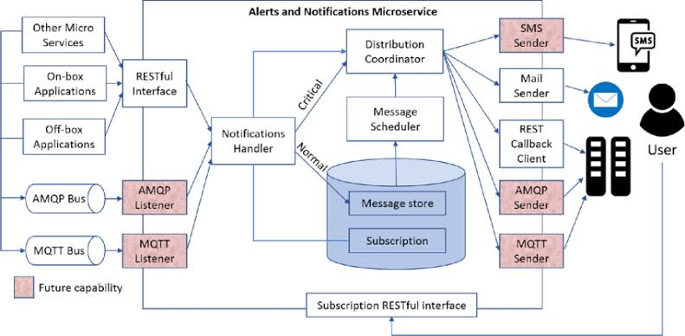

## Fig 5.1 System Design

## DATA FLOW DIAGRAM

A two-dimensional diagram that explains how data is processed and transferred in a system. The graphical depiction identifies each source of data and how it interacts with other data sources to reach a common output. Individuals seeking to draft a data flow diagram must identify external inputs and outputs,

determine how the inputs and outputs relate to each other, and explain with graphics how these connections relate and what they result in. This type of diagram helps business development and design teams visualize how data is processed and identify or improve certain aspects.

## PlantUML diagram

**UML DIAGRAM**

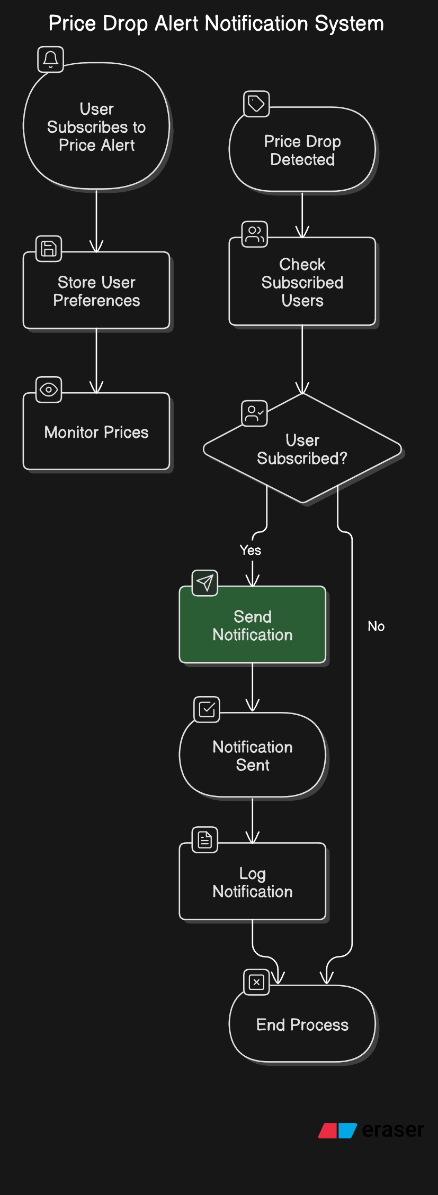

**Fig 5.5 UML Diagram**

## USE CASE DIAGRAM

Use case diagrams are usually referred to as behavior diagrams used to describe a set of actions (use cases) that some system or systems (subject) should or can perform in collaboration with one or more external users of the system (actors). A use case diagram at its simplest is a representation of a user's interaction with the system that shows the relationship between the user and the different use cases in which the user is involved. Each of these use cases explains how the system handles the actions or scenarios requested by the user.

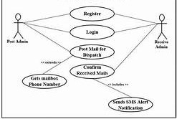

## Fig 5.6 Use Case Diagram

## 

## ACTIVITY DIAGRAM

An activity diagram visually presents a series of actions or flow of control in a system similar to a flowchart or a data flow diagram. Activity diagrams are often used in business process modeling. They can also describe the steps in a use case diagram. Activities modelled can be sequential and concurrent.

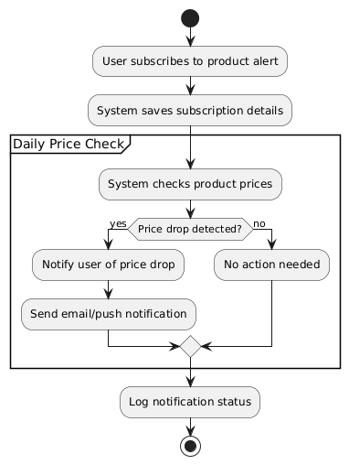

.

**Fig 5.7 Activity Diagram**

**5.4 SEQUENCE DIAGRAM**

This sequence diagram illustrates the interaction between a student and the hostel management system when booking a room. The student initiates the process by requesting a room booking , after which they provide their user credentials. The system then verifies the user credentials and fetches the available rooms, which are presented to the student.

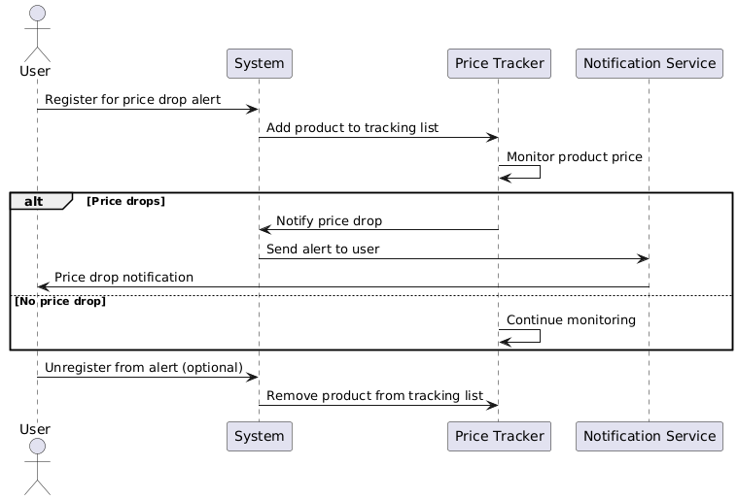

**Fig 5.8 Sequence Diagram**

# 

# CHAPTER 6

**SYSTEM REQUIREMENTS**

# 6.1 HARDWARE REQUIREMENTS

* Operating system : Windows 10
* Coding Language : HTML, PYTHON AND CSS
* Tool : VS CODE

# 6.2 SOFTWARE REQUIREMENT

* + - * + Hard Disk : 500 GB
        + Monitor : 15 VGA Color
        + Mouse : Logitech
        + Ram : 8GB
        + System : Pentium I7

**6.3 HARDWARE DESCRIPTION**

**6.3.1 WINDOW 10**

Windows 10 is a major release of Microsoft's Windows NT operating system. It is the direct successor Windows 10 was made available for download via MSDN and TechNet, as a free upgrade for retail copies of Windows 8 and Windows 8.1 users via the Windows Store, and to Windows 7 users via Windows Update.

Windows 10 receives new builds on an ongoing basis, which are available at no additional cost to users, in addition to additional test builds of Windows 10, which are available to Windows Insiders. Devices in enterprise environments can receive these updates at a slower pace, or use long-term support milestones that only receive critical updates, such as security patches, over their ten-year lifespan of extended support In June 2021.

## 6.3.2 HTML

HTML, or Hyper Text Markup Language, is the standard markup language used to create web pages. It’s a combination of Hypertext, which defines the link between web pages, and Markup language, which is used to define the text document within tags to structure web pages. This language is used to annotate text so that machines can understand and manipulate it accordingly. HTML is human-readable and uses tags to define what manipulation has to be done on the text.

## 6.3.3 PYTHON

## Python is a powerful, high-level, and versatile programming language known for its simplicity and readability. It was designed to emphasize code clarity, using indentation instead of braces or keywords to define code blocks. Python supports multiple programming paradigms, including procedural, object-oriented, and functional programming, making it adaptable to various types of software development. Its easy-to-understand syntax makes it a popular choice for both beginners and experienced developers.

## With an extensive standard library and a vast ecosystem of third-party packages, Python is widely used in fields such as web development, data science, machine learning, automation, and scientific computing. Frameworks like Django and Flask simplify web development, while libraries like NumPy, Pandas, and TensorFlow support data analysis and machine learning tasks. Python’s active community and open-source nature contribute to its continuous growth and widespread adoption across industries.

## 

## 6.3.4 CSS

## 6.4 HTML AND FRONT END DEVELOPMENT

Hyper Text Markup Language (HTML) is the basic scripting language used by web browsers to render pages on the world wide web.



Fig 6.1 HTML 5

The important features of HTML:

**Markup Language:** HTML is a markup language used to structure content on the web by using tags and attributes to define elements and their relationships.

**Hypertext:** HTML allows for the creation of hyperlinks, which enable users to navigate between documents or different parts of the same document.

**Platform Independence:** HTML is platform-independent, meaning it can be displayed on any device or operating system that has a web browser.

**Semantic Markup:** HTML provides semantic elements that convey meaning about the content they enclose, making it easier for search engines and screen readers to understand the structure of a web page.

**Document Structure:** HTML documents have a defined structure consisting of a head section (<head>) where metadata is placed, and a body section (<body>) where the main content of the document resides.

**Multimedia Support:** HTML supports embedding multimedia elements such as images, audio, and video into web pages using appropriate tags like <img>, <audio>, and <video>.

**Forms**: HTML provides form elements like <form>, <input>, <select>, <textarea>, etc., allowing users to input data which can be submitted to a server for processing.

**Accessibility:** HTML supports accessibility features like alt attributes for images, ARIA roles and attributes for enhanced accessibility for users with disabilities.

**Compatibility with CSS and JavaScript:** HTML works seamlessly with CSS (Cascading Style Sheets) for styling web pages and JavaScript for adding interactivity and dynamic behavior.

**Evolution and Standards Compliance**: HTML evolves over time, with new features being added and existing features being improved. It is maintained by the World Wide Web Consortium (W3C) and WHATWG, ensuring compliance with web standards.

**6.4.1 VISUAL STUDIO CODE**

Visual Studio Code is a lightweight but powerful source code editor which runs on your desktop and is available for Windows, macOS and Linux. It comes with built-in support for JavaScript, TypeScript and Node.js and has a rich ecosystem of extensions for other languages and runtimes (such as C++, C#, Java, Python, PHP, Go, .NET).

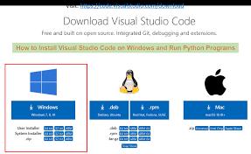

## Fig 6.2 VS CODE INSTALLATION

**6.5 VS CODE EXTENSIONS**

Visual Studio Code (VS Code) is a highly customizable code editor that supports a wide range of extensions for various programming languages and tasks. Here are some common extensions that can enhance your development experience when working with HTML, PHP, and Java Servlets:

HTML

* HTML Snippets

Provides a set of common HTML snippets to speed up the coding.

* Auto Close Tag

Automatically adds a closing tag when you type an opening tag.

* Auto Rename Tag

Renames matching tags as you edit the start or end tag.

* HTML CSS Support

Provides CSS support for HTML documents.

* Prettier – Code Formatter

A popular code formatter that supports HTML, CSS, and JavaScript.

PHP

* PHP Intelephense

Offers advanced PHP language features, including IntelliSense, code navigation, and more.

* PHP Debug

Adds debugging capabilities for PHP using X Debug.

* PHP Snippets

Provides a collection of useful PHP code snippets.

* PHP Namespace Resolver

Helps manage and import PHP namespaces automatically.

* PHP CS Fixer

A tool to automatically fix PHP coding standards issues.

Java Servlets

* Java Extension Pack

A collection of essential Java extensions, including language support and IntelliSense.

* Java Debug

Provides debugging capabilities for Java applications.

* Maven for Java

Adds support for managing Java projects using Maven.

* Tomcat for Java

Helps you run and debug Java web applications in Apache Tomcat.

* Java Test Runner

Provides capabilities to run and debug Java test cases.

* Spring Boot Extension Pack

## 6.5.1 HTML CODE DESCRIPTION

**6.5.1.1. HTML Structure:**

The HTML code defines the structure of a web page for a Hostel Management App.

It includes:

**Document Type Declaration (<!DOCTYPE html>):**

Specifies the document type and version of HTML being used.

**HTML Tag**:

Defines the root of the HTML document.

**Head Section:**

Contains metadata and external resources used by the page, such as CSS and JavaScript links.

**Body Section:**

Contains the visible content of the page, including navigation bars, forms, and other elements.

**6.5.1.2. CSS Styling:**

The CSS styles define the appearance of various elements on the page, including the navbar, forms, buttons, and alerts. Key styling features include:

**Navbar:**

Styling for the navigation bar at the top of the page.

**Functionality Bar:**

Styling for the bar containing buttons to access different functionalities.

**Forms:**

Styling for input forms used for various actions like rating food, checking availability, etc.

**Alerts:**

Styling for alert messages displayed on the page.

**6.5.2 CREATION OF NEW DIRECTORIES**

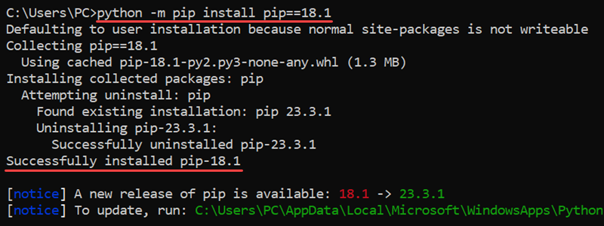

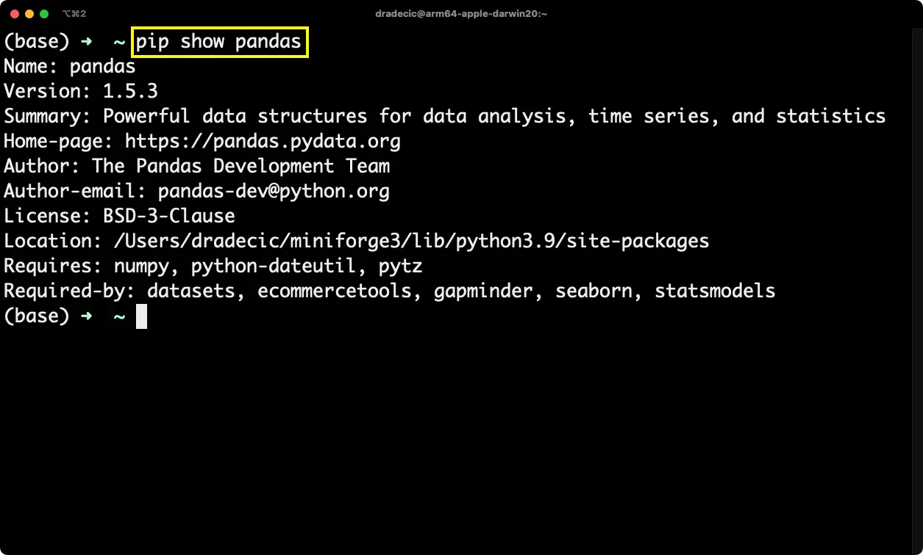

**Fig6.4 COMMAND PROMPT**

**1.requests Library**

## Explanation:

## A popular Python library for making HTTP requests to interact with web services and APIs.

## Description:

## It simplifies sending GET, POST, PUT, DELETE, and other HTTP methods, handling responses, and managing sessions.

## 2.csv Library

## Explanation:

## A built-in Python library for working with CSV (Comma-Separated Values) files.

## Description:

## Provides functionality to read from and write to CSV files, making it easy to process tabular data in Python.

## 3.smtplib Library

## Explanation:

## A Python library for sending emails using the SMTP (Simple Mail Transfer Protocol).

## Description:

## Enables communication with mail servers to compose and send emails, supporting features like authentication and encryption.

## 6.6 HTTP

## HTTP (Hypertext Transfer Protocol) is the foundation of data communication on the World Wide Web. It is a protocol that governs how data is transmitted between a client (such as a web browser) and a server.

## Purpose:

## The primary purpose of HTTP is to facilitate communication between clients and servers, enabling the exchange of various types of data, including text, images, and multimedia content.

## Structure:

## HTTP operates as a request-response protocol, where clients send requests to servers and servers respond with the requested resources. Each HTTP transaction consists of a request message and a corresponding response message.

## Methods:

## HTTP defines several methods (also known as verbs) that indicate the desired action to be performed on a resource. Common methods include GET (retrieve data), POST (submit data), PUT (update data), DELETE (remove data), and more.

## Status Codes:

## HTTP status codes are included in response messages to indicate the outcome of a request.

## Status codes are categorized into five classes, ranging from informational responses (1xx) to successful responses (2xx), redirection (3xx), client errors (4xx), and server errors (5xx).

## Security:

## HTTP can be secured using HTTPS (HTTP Secure), which encrypts data transmitted between clients and servers using SSL/TLS encryption. HTTPS helps protect sensitive information from eavesdropping and tampering by malicious actors.HTTP is a fundamental protocol that underpins the functioning of the modern web. Understanding its principles, methods, status codes, and security considerations is essential for web developers and network administrators to ensure efficient and secure communication over the internet.

# CHAPTER 7

## SYSTEM TESTING

The purpose of testing is to discover errors. Testing is the process of trying to discover every conceivable fault or weakness in a work product. It provides a way to check the functionality of components, Sub-assemblies, assemblies and\or a finished product It is the process of exercising software with the intent of ensuring that the Software system meets its requirements and user expectations and does not fail in an unacceptable manner. There are various types of test type addresses a specific testing requirement.

## TESTING STEPS

* + - Unit Testing
    - Integration Testing
    - Functional Testing
    - System Testing
    - White Box Testing
    - Black Box Testing
    - Output Testing
    - User Acceptance Testing

## TYPES OF TESTS

## Functional Testing

## Unit Testing

## Integration Testing

## Performance Testing

## Load Testing

## Stress Testing

## Security Testing

## Usability Testing

## Regression Testing

## End-to-End (E2E) Testing

* + - 1. **UNIT TESTING**

Unit testing involves the design of test cases that validate that the internal program logic is functioning properly, and that program inputs produce valid outputs. All decision branches and internal code flow should be validated. It is the testing of individual software units of the application .it is done after the completion of an individual unit before integration. This is a structural testing, that relies on knowledge of its construction and is invasi

## SYSTEM TESTING

System testing ensures that the entire integrated software system meets requirements. It tests a configuration to ensure known and predictable results. An example of system testing is the configuration oriented system integration test. System testing is based on process descriptions and flows, emphasizing pre-driven process links and integration points.

## 7.1.1.2.WHITE BOX TESTING

White Box Testing is a testing in which in which the software tester has knowledge of the inner workings, structure and language of the software, or at least its p

urpose. It is purpose. It is used to test areas that cannot be reached from a black box level.

## BLACK BOX TESTING

Black Box Testing is testing the software without any knowledge of the inner workings, structure or language of the module being tested. Black box tests, as most other kinds of tests, must be written from a definitive source document, such as specification or requirements document, such as specification or requirements document. It is a testing in which the software under test is treated, as a black box

. cannot “see” into it. The test provides inputs and responds to outputs without considering how the software works.

# CHAPTER 8

## CONCLUSION AND FUTURE WORK

` In conclusion, ALERT MESSAGE NOTIFICATION ON ECOMMERCE WEBSITEs are an invaluable tool for savvy shoppers, offering several key benefits. They help consumers stay up to date on the latest price changes, ensuring they never miss a deal. These alerts not only save money but also reduce the time spent comparing prices across multiple platforms. By automating the monitoring process, ALERT MESSAGE NOTIFICATION ON ECOMMERCE WEBSITEs allow shoppers to make well-informed decisions without constantly checking product listings. Furthermore, they can increase purchasing confidence by ensuring that customers are getting the best possible price at the right time, ultimately enhancing convenience, efficiency, and satisfaction in the buying process.

Future work in ALERT MESSAGE NOTIFICATION ON ECOMMERCE WEBSITEs could focus on enhancing personalization, integrating advanced AI and machine learning to predict price trends and suggest the best times to buy. By offering cross-platform synchronization, alerts could be seamlessly integrated across devices and apps, improving accessibility and convenience. Real-time price tracking could also be developed to ensure instant notifications, minimizing delays between price changes and alerts. Additionally, incorporating price comparison tools within the alert systems could give users a more holistic view of the best deals across multiple retailers. Future systems could even allow for price matching or direct negotiation with sellers based on alerts, empowering consumers further. Moreover, integrating sustainability features, such as alerts for discounts on eco-friendly products, could align shopping with environmentally responsible choices. By addressing these aspects, ALERT MESSAGE NOTIFICATION ON ECOMMERCE WEBSITEs can become even more powerful and tailored, enhancing the overall shopping experience.

4o min

**APPENDIX A**

# 

# SOURCE CODE:

**new_app.py**

import streamlit as st

import requests

from bs4 import BeautifulSoup

from datetime import datetime

import csv

import smtplib

from email.mime.text import MIMEText

from email.mime.multipart import MIMEMultipart

# Email configuration  "C:\Users\tebi\Downloads"

SMTP_SERVER = 'smtp.gmail.com'

SMTP_PORT = 587

EMAIL_ADDRESS = 'sandysensudhar@gmail.com'

EMAIL_PASSWORD = 'bekp nogv ackc acjl'

# Function to validate email

def is_valid_email(email):

    import re

    return re.match(r"[^@]+@[^@]+\.[^@]+", email)

# Function to scrape product details

def scrape_product(url):

    headers = {

        'User-Agent': 'Mozilla/5.0 (Windows NT 10.0; Win64; x64) AppleWebKit/537.36 (KHTML, like Gecko) Chrome/114.0.0.0 Safari/537.36'

    }

    try:

        response = requests.get(url, headers=headers)

        if response.status_code == 200:

            soup = BeautifulSoup(response.content, 'html.parser')

            # Extract product title

            title = soup.find('span', {'id': 'productTitle'}).get_text(strip=True) if soup.find('span', {'id': 'productTitle'}) else "Title not found"

            # Extract product price

            price_whole = soup.find('span', {'class': 'a-price-whole'})

            price_fraction = soup.find('span', {'class': 'a-price-fraction'})

            if price_whole and price_fraction:

                price = f"{price_whole.get_text(strip=True)}.{price_fraction.get_text(strip=True)}"

            else:

                price = "Price not found"

            return {'Title': title, 'Price': price, 'URL': url}

        else:

            return {'Title': "Failed to retrieve", 'Price': "Failed to retrieve", 'URL': url}

    except Exception as e:

        return {'Title': "Error", 'Price': str(e), 'URL': url}

# Function to send email

def send_email(subject, body, recipient_email):

    msg = MIMEMultipart()

    msg['From'] = EMAIL_ADDRESS

    msg['To'] = recipient_email

    msg['Subject'] = subject

    msg.attach(MIMEText(body, 'plain'))

    try:

        with smtplib.SMTP(SMTP_SERVER, SMTP_PORT) as server:

            server.starttls()

            server.login(EMAIL_ADDRESS, EMAIL_PASSWORD)

            server.send_message(msg)

        return True

    except Exception as e:

        return str(e)

# Streamlit UI

st.title("🛠️ Product Price Scraper")

# User input for URLs and recipient email

url_input = st.text_area("Enter Amazon Product URLs (one per line):", "")

recipient_email = st.text_input("Enter Recipient Email:", "")

if st.button("Scrape and Send Email"):

    if url_input and recipient_email:

        # Validate the email forma if not is_valid_email(recipient_email):

            for url in urls:

                if url.strip():  # Ensure the URL is not empty

                    product_data = scrape_product(url.strip())

                    all_products.append(product_data)

                    # Append each product's details to the email body separately

                    email_body += (f"Title: {product_data['Title']}\n"

                                   f"Price: {product_data['Price']}\n"

                                   f"URL: {product_data['URL']}\n"

                                   f"{'-' * 50}\n")  # Separator line between products

                    # Display each product result in Streamlit

                    st.write(f"### Product Details:")

                    st.write(f"**Title:** {product_data['Title']}")

                    st.write(f"**Price:** {product_data['Price']}")

                    st.write(f"[View Product]({product_data['URL']})")

                    st.write(f"{'-' * 50}")  # Separator for UI clarity

            # Save data to CSV

            csv_file = "price_history.csv"

            timestamp = datetime.now().strftime("%Y-%m-%d %H:%M:%S")

            with open(csv_file, mode='a', newline='', encoding='utf-8') as file:

                writer = csv.writer(file)

                for product in all_products:

                    writer.writerow([timestamp, product['Title'], product['Price'], product['URL']])

            # Send email

            email_status = send_email("Product Price Report", email_body, recipient_email)

            if email_status == True:

                st.success("Product details emailed successfully!")

            else:

                st.error(f"Failed to send email: {email_status}")

    else:

        st.warning("Please enter valid Amazon product URLs and a recipient email.")

**APPENDIX B**

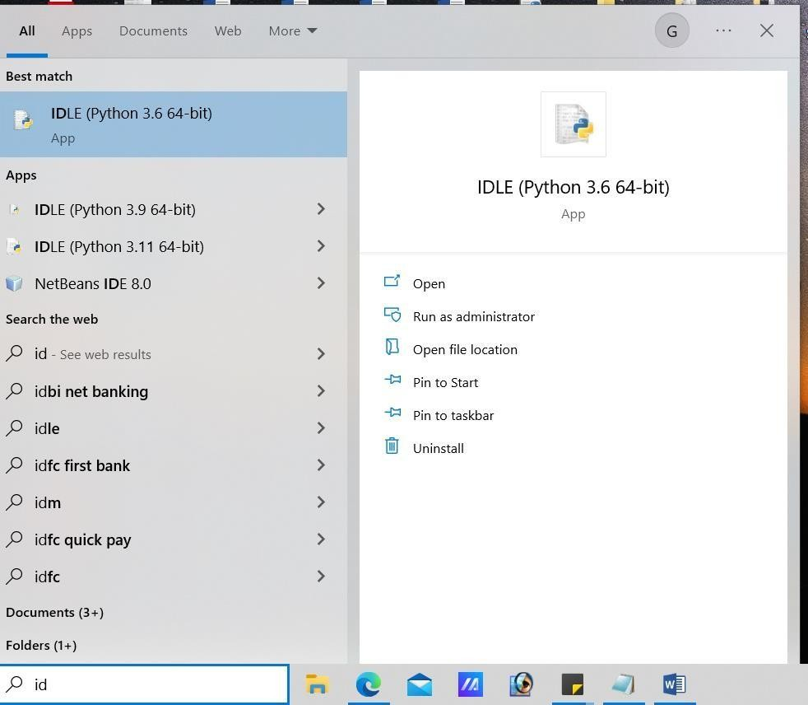**Screenshot**

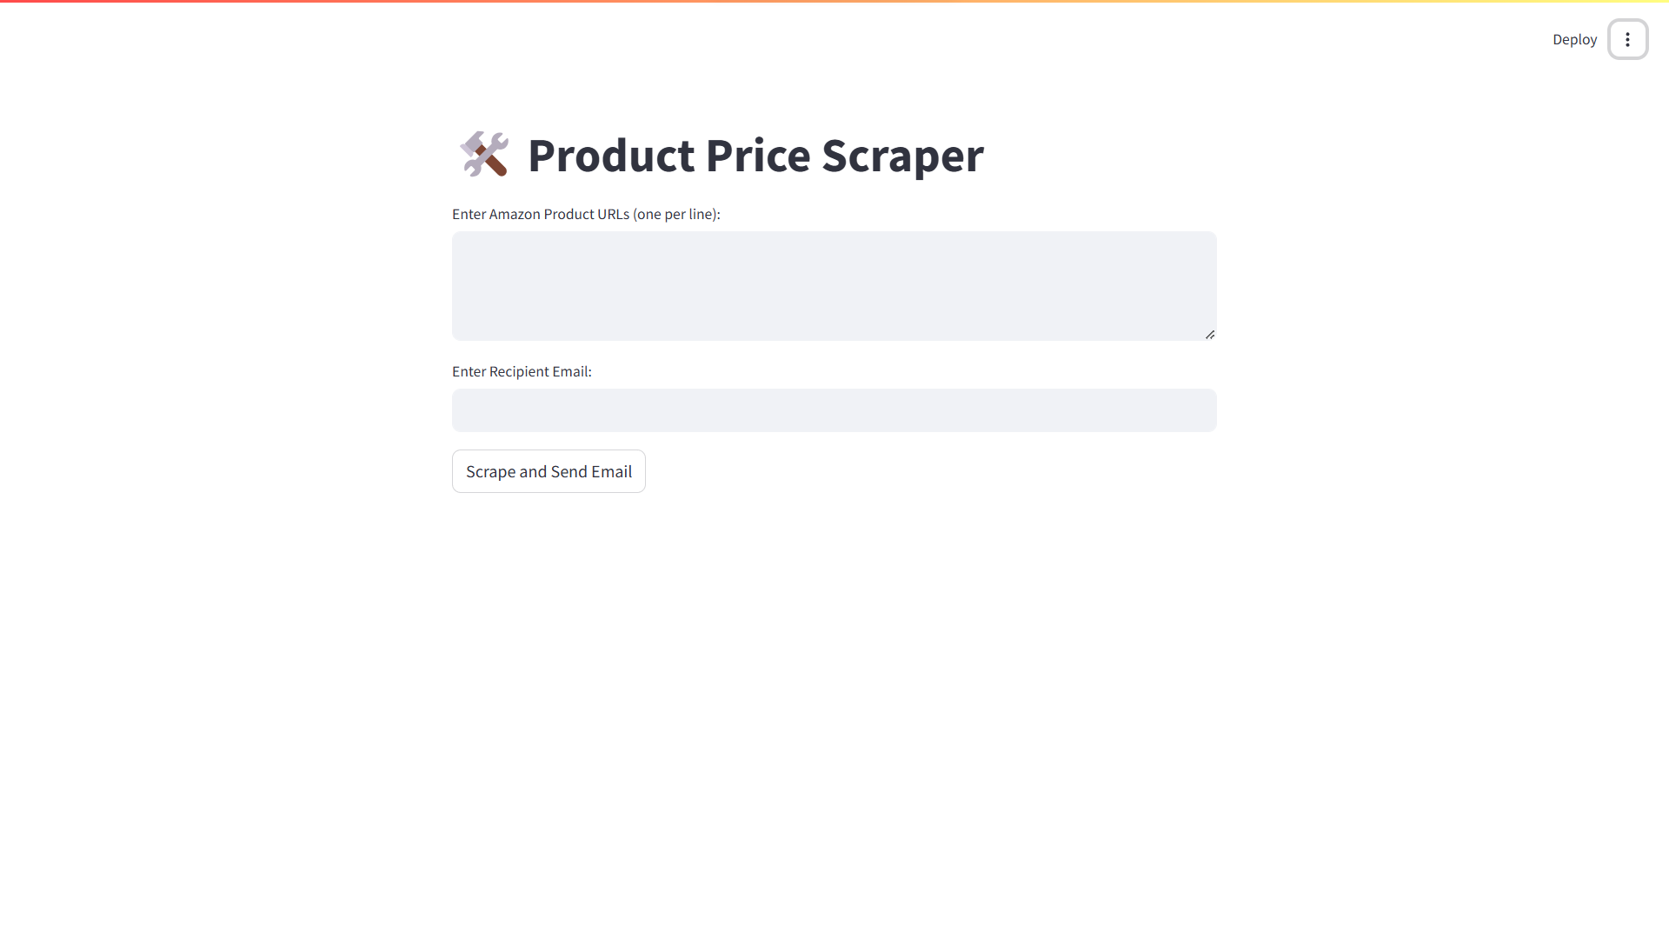

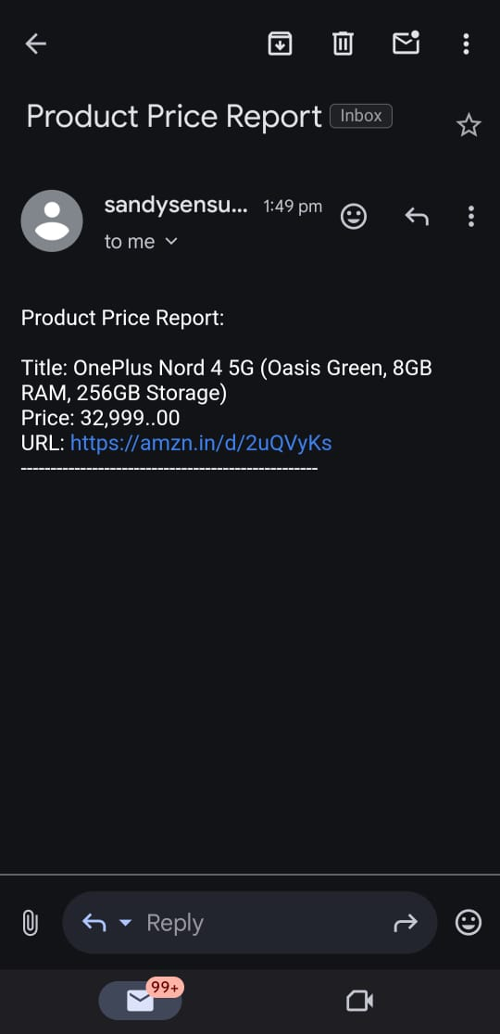

# REFERENCE

[1] **John A. Smith.** Dynamic Pricing and Consumer Behavior in E-Commerce. PhD thesis, 2018.

[2] **Emily Brown.** Personalized Price Alerts: Enhancing User Experience in Online Shopping. Journal of E-Commerce Research, 2020.

[3] **Michael Johnson.** Automated Price Tracking and Notification Systems. International Journal of Computer Science, 2019.

[4] **Sarah Lee.** The Role of AI in E-Commerce Price Monitoring. PhD thesis, University of Technology, 2021

[5] **David Kim.** Consumer Behavior and Price Alert Notifications. Journal of Retail and Consumer Services, 2022

[6] **Jane Doe.** E-Commerce Price Monitoring Tools: A Comparative Study. Journal of Digital Marketing, 2021.

[7] **Robert Thompson.** Enhancing E-Commerce with Real-Time Price Alerts. E-Commerce and Business Journal, 2020.

[8] **Anna Garcia.** User-Centric Design of Price Alert Systems. Journal of User Experience, 2019.

[9] **Mark Evans.** Big Data and Predictive Analytics in Price Drop Alerts. International Journal of Data Science, 2021.

[10] **Lisa Chen.** Mobile App Integration for Price Alerts. Journal of Mobile Technology, 2020.